Folk Music Society of New York, Inc. / New York Pinewoods Folk Music Club
Please Announce: [Release date: Sept. 23,2008 -- For immediate release.]
A Daniel Pearl World Music Days Concert
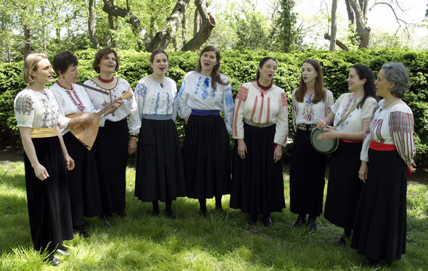
World Music Concert: SVITANYA
Eastern European Women's Vocal Ensemble
Friday, October 24, 2008 at 8:00 PM
(Note corrected start time.)
Preceded by singing workshop at 6:30pm
At OSA, 220 E. 23 Street, suite 707 (between 2nd & 3rd Ave)
SVITANYA (svee-TAH-nya), which means “the light at sunrise” in Croatian and Ukrainian, is a women’s a cappella ensemble that specializes in music from Eastern Europe. The songs they perform exude the spirit of traditional village music. Some songs are modern arrangements, some songs were learned from village source recordings, and all songs are sung in their original languages.
The concert will start at 8:00 PM at the Organization of Staff Analysts Hall (OSA), 220 E. 23 Street, suite 707 (between 2nd & 3rd Ave). A pre-concert (6:30 pm) workshop on Eastern European Singing Style for an admission of $10 will include the teaching of a song or two. Concert admission is $20; or $12 for seniors or low income individuals. Full-time students 22 and under are admitted free, as are FMSNY and OSA members. Tickets can be purchased at the door, or on line at: www.folkconcert1.eventbrite.com. For information call 718-672-6399 or on the web at www.folkmusicny.org
Their diverse repertoire ranges from strong and strident field-working songs to traditional dance tunes to lush and emotive arrangements, and it all celebrates the timbres, rhythms, and harmonies indigenous to the region. Most every song tells a story; some songs celebrate the mundane events of daily life, like cutting wheat in the fields or strolling in the street with musicians, and others depict life’s more poignant moments, such as losing a loved one to war or being married off while too young.
This concert is part of the Daniel Pearl World Music Days, an annual worldwide network of concerts that uses the universal language of music to diminish hatred, respect differences, and reach out in global friendship. Daniel Pearl was an American journalist who was kidnapped and murdered by terrorists in Pakistan in 2002. He was also an accomplished classical violinist, country fiddler, and mandolin player who joined musical groups wherever he traveled. Daniel Pearl would have celebrated his 45th birthday on October 10th, and this concert honors him by carrying on his mission of celebrating our shared humanity through music. This project is partially supported by a grant from Pennsylvania Performing Arts on Tour, a program developed and funded by The Heinz Endowments; the William Penn Foundation; the Pennsylvania Council on the Arts, a state agency; and The Pew Charitable Trusts; and administered by Mid Atlantic Arts Foundation.
-- 00 --
Pictures and an electronic version of this release are at http://www.folkmuiscny.org/press.
The Folk Music Society of New York, Inc. hosts concerts for music lovers who can relax and listen, sing along on the chorus, or dance in the aisles to the best of traditional music. For more information go online to www.folkmusicny.org.
Accredited members of the press are always welcome at our events. Tear-sheets are appreciated. Press contact Rosalie Friend, (718) 965-4074, a.friend@mindspring.com, for further information.
The Folk Music Society of New York, Inc. / New York Pinewoods Folk Music Club is a non-profit 501(c)(3) educational corporation, an affiliate of the Country Dance and Song Society of America and a member of the Folk Alliance. It is run by a volunteer Board of Directors, elected by the membership. For "do-it-yourself singers” we host informal participatory singing four times a month: sea chanteys, sacred harp, a community open sing, and gospel/sacred harp We also run concerts, weekends, classes, and singing parties, all with an emphasis on traditional folk music of all flavors. Office: 444 West 54th St, #7, New York NY 10019.
Visit our website: www.folkmusicny.org

