Folk Music Society of New York, Inc. / New York Pinewoods Folk Music Club

January 2, 2013 For immediate release, please

Weekend of Folk Music in Kerhonkson, NY
Friday, February 8 – Sunday, February 10, 2013

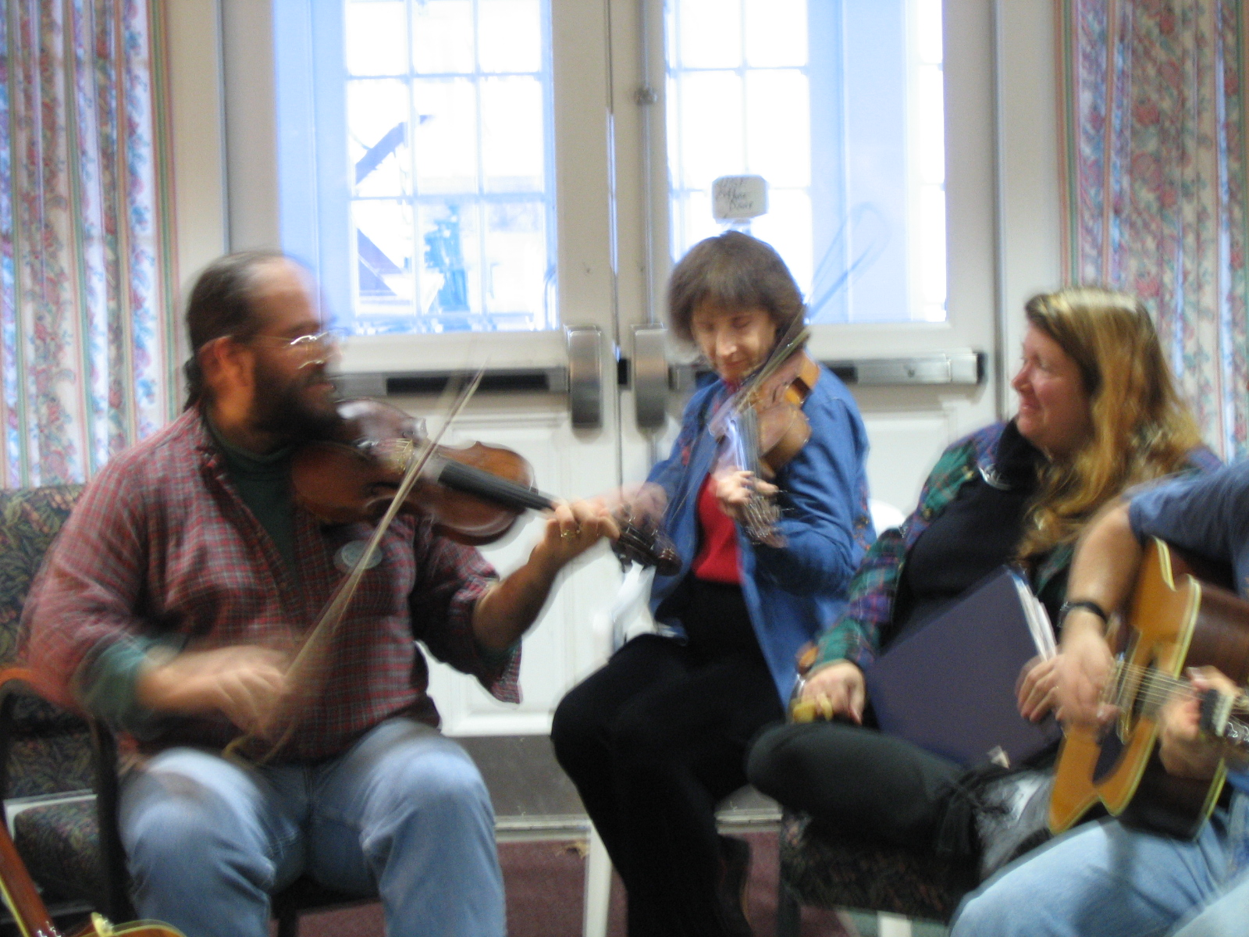
The Folk Music Society of New York announces its annual Weekend of Music. This is a friendly getaway filled with informal participatory music making; a weekend with music all around. You'll find instrumental jams, ballad singing, contemporary songs, traditional songs, and whatever! And, yes, there are also jigsaw puzzles and people out skiing, shopping, and hiking.

The Weekend is held at the Hudson Valley Resort and Spa in Kerhonkson, NY 2446, nestled in the Shawangunk Mountains, 100 miles north of New York City. More information, weekend and day rates, and a reservation form are available at www.folkmusicny.org. Reservations may also be made directly online at http://bit.ly/RqiyXW. Information by phone: 718-672-6399.

The Folk Music Society of New York, Inc. / New York Pinewoods Folk Music Club, an all volunteer organization, tries to maximize participation in traditional music by running events that are so much fun that no one can resist joining in. For more information on the web, go to www.folkmusicny.org

----------------------- 00 ----------------------

An electronic version of this release and photos are available at: www.folkmuiscny.org/press
Press contact Rosalie Friend, (718) 965-4074, publicity@folkmusicny.org, for further information or to receive releases by e-mail in the future.
The Folk Music Society of New York, Inc. / New York Pinewoods Folk Music Club is a non-profit 501(c)(3) educational corporation, an affiliate of the Country Dance and Song Society of America. It is run by a volunteer Board of Directors, elected by the membership. It runs concerts, weekends, classes, singing parties, and get-togethers, all with an emphasis on traditional folk music of all flavors. Office: 444 West 54th St, #7, New York NY 10019
Visit our website: www.folkmusicny.org

