CONTACT FOR IMMEDIATE RELEASE PLEASE Press interviews:
Lynn Cole hwood50(at)aol.com
919-308-9526
lynncole10(at)gmail.com
Concert: Plainsong - Iain Matthews & Andy Roberts
Veterans of folk and folk rock from across the pond - unplugged

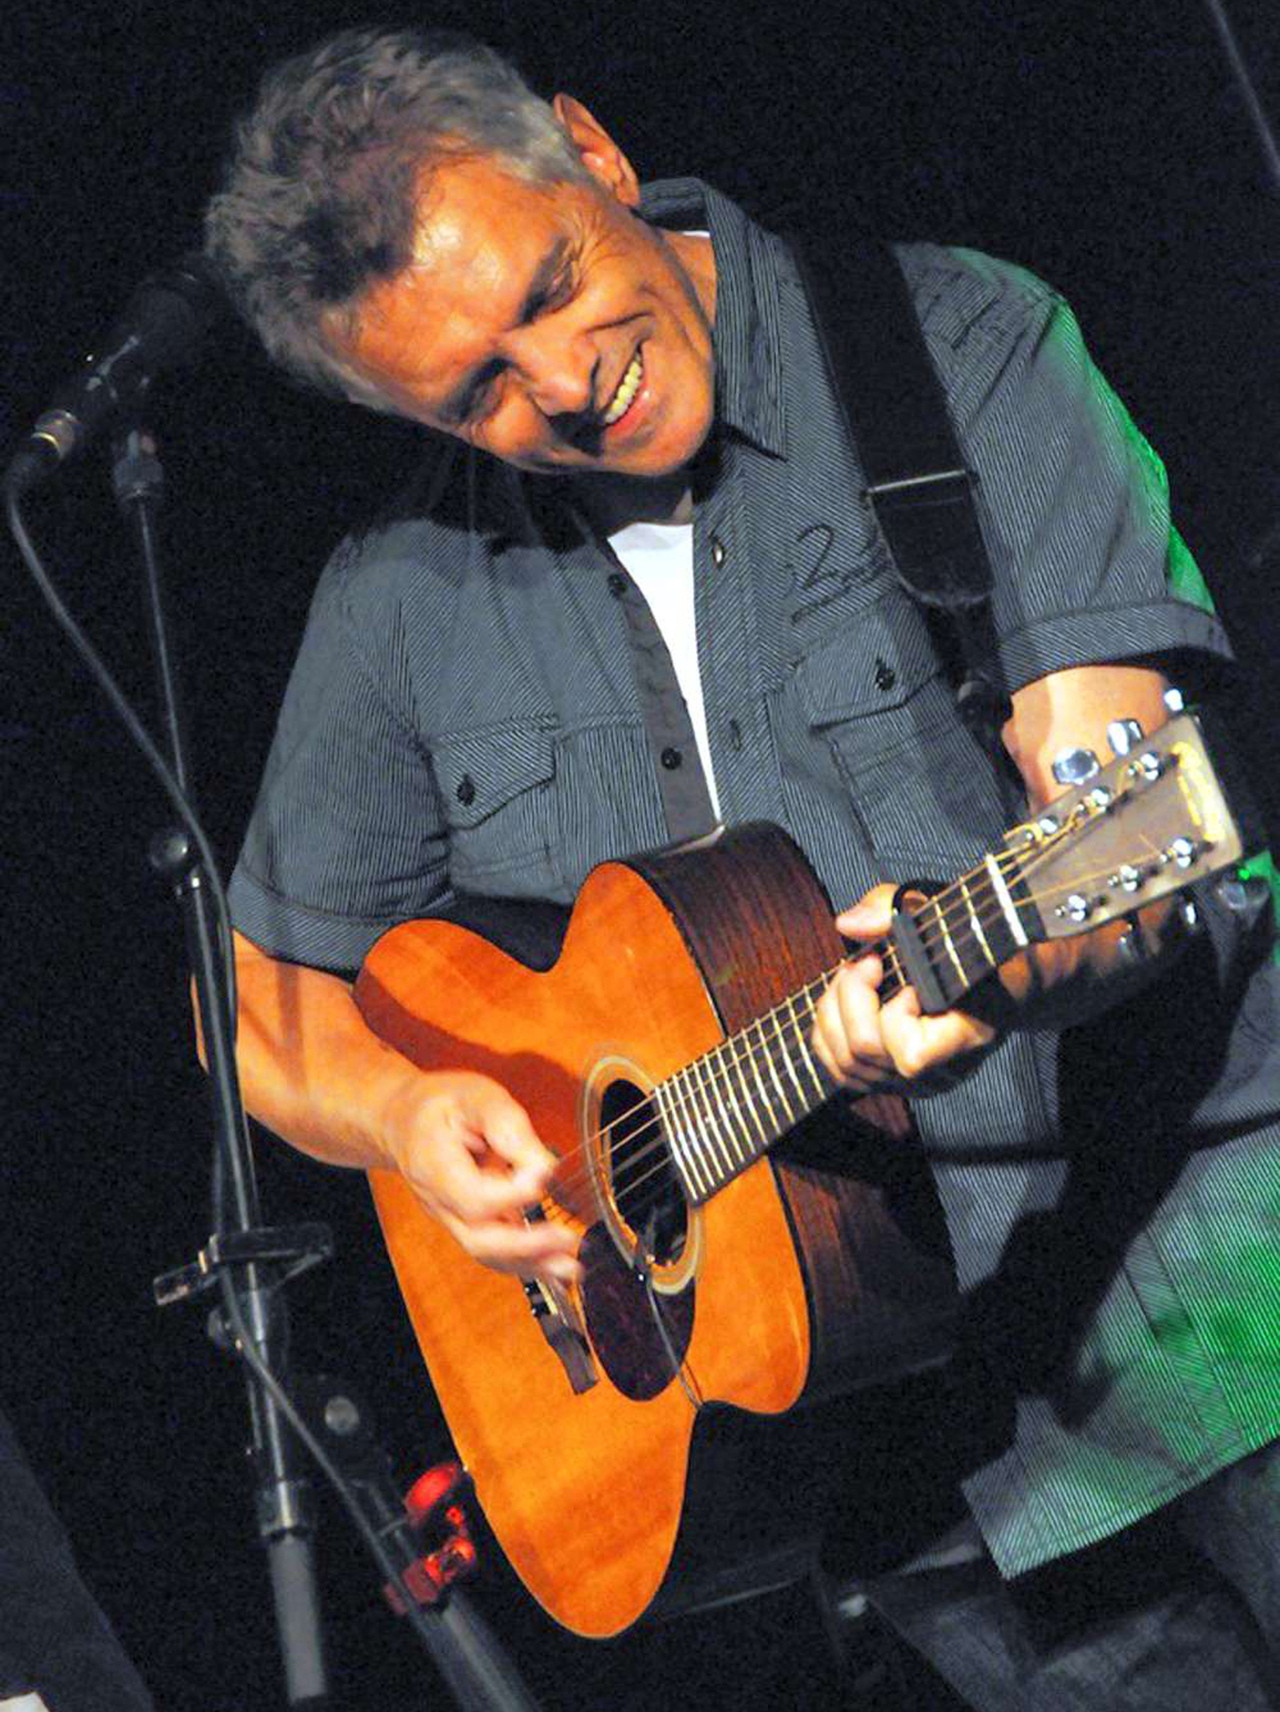
Concert: Plainsong - Iain Matthews & Andy Roberts in concert, presented by the Folk Music Society of NY (www.folkmusicny.org), Thursday, April 7th; 7:30pm. The concert is at the OSA Hall, 7th floor, 220 E 23rd St., between 2nd & 3rd Aveues in Manhattan. Contribution: $20 general public; $18 Folk Music Society of NY members. Note the earlier start time on this weeknight, 7:30pm, doors open at 7:00pm.

Iain was a founding member of the British folk rock band, Fairport Convention, appeared on the band's first three recordings (Fairport Convention, What We did on our Holidays, and Unhalfbricking). He next formed his own band, Matthews Southern Comfort, and had a massive European hit with the Joni Mitchell song "Woodstock." Iain is a prolific songwriter, a superb singer, an accomplished guitarist. Iain’s website: www.iainmatthews.nl

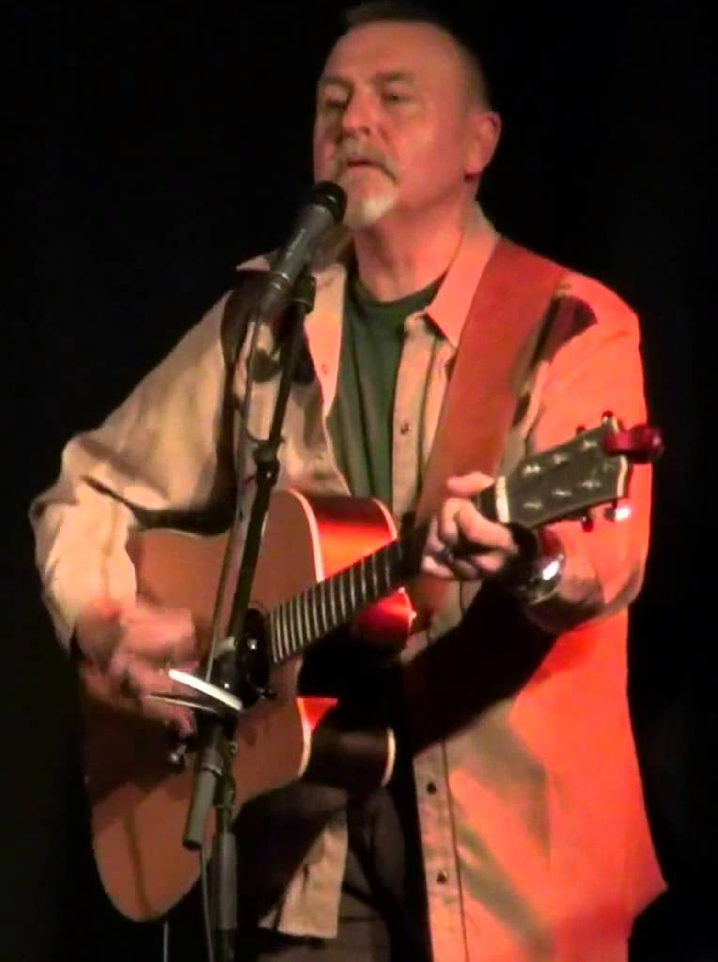
Andy has been playing various instruments since he was a kid. He's performed with numerous bands, including The Liverpool Scene, Pink Floyd, and The Albion Band. He and Iain have played together on and off since the early Seventies. Andy’s website: www.andyrobertsmusic.com
- # # # -

