Folk Music Society of New York, Inc. / New York Pinewoods Folk Music Club
For immediate release, please
Happy Traum, Folksinger and Guitar Virtuoso
Friday, June 17, 2011
At OSA Hall, 220 E. 23rd St, Suite 707 (between 2nd & 3rd Avenues), New York, 10010
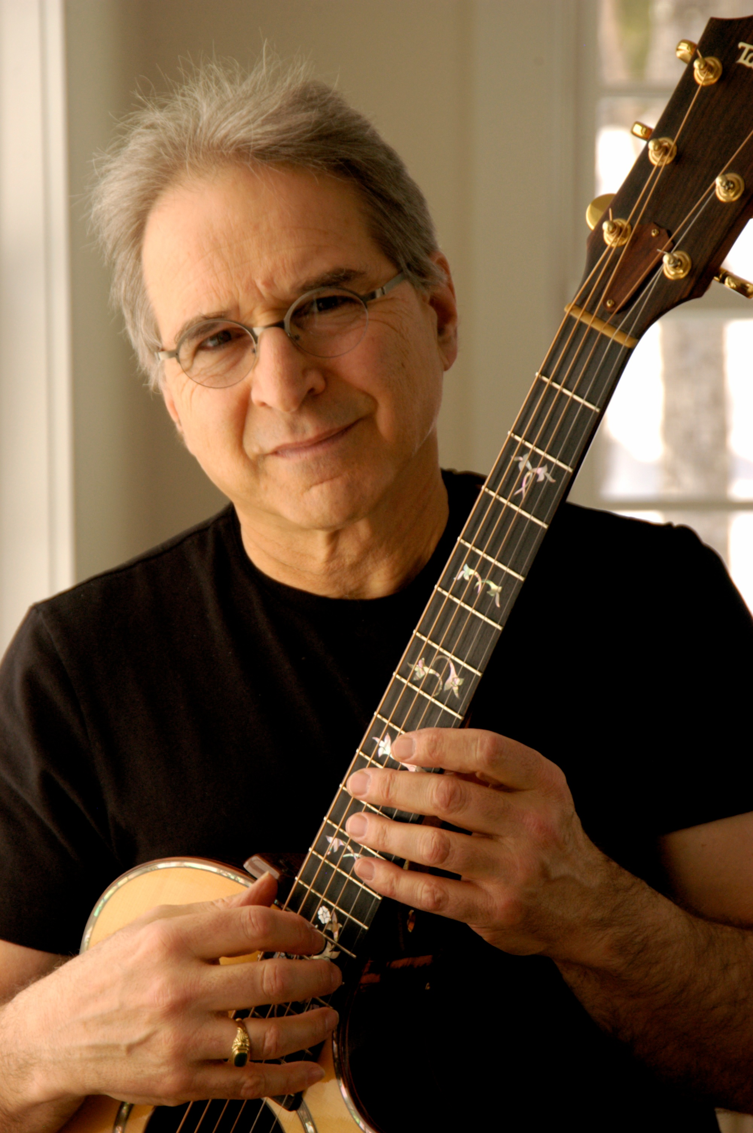
Happy Traum "defined the Northeast folk music style"says Rolling Stone. His infectious singing and outstanding guitar playing are in demand throughout the U.S., Canada, Europe, Australia, and Japan, in performance as a soloist and as a member of various groups. His avid interest in traditional and contemporary music has brought him recognition as a performer, recording artist, writer, editor, session musician, folklorist, and teacher.
Happy Traum began playing guitar and 5-string banjo as a teenager, amidst the legendary Greenwich Village folk scene of the 1950s and ‘60s. Happy first appeared on record in 1963 with a group of young folk musicians, including Bob Dylan, Phil Ochs, Pete Seeger, Peter LaFarge and The Freedom Singers in an album called "Broadside, Vol.1." Happy cut the first recorded version of "Blowin' In The Wind," Since then appearing solo, with his brother, Artie, with Bob Dylan, and others, Happy Traum has produced 21 recordings. Happy toured extensively alone and with his brother appearing in concerts, at music camps, and at countless festivals here and abroad.

Happy has also made a mark as a teacher, writer, and publisher. Many people learned to play guitar from his 1965 book, "Fingerpicking Styles for Guitar" and the dozen books that followed it. In 1967 Happy, with his wife and partner, Jane Traum, founded Homespun Tapes, and have built it into one of the world's leading producers of audio and video music instruction. An expert guitar and banjo player, Happy produces all of the lessons for Homespun and brings to it his many years of experience as a performer, writer, editor, folklorist, teacher and recording artist. He also served as editor of Sing Out and has published articles in Rolling Stone, and numerous other magazines.

Join us Friday, May 20, at 8:00 pm at OSA Hall, 220 E. 23rd Street, suite 707, between 2nd and 3rd Avenues. General Admission is $20; children, and full-time students under 22 are free. Tickets are available at the door or online at http://brownpapertickets.com/event/178635. More details and information at:www.folkmusicny.org ; or 212-957-8386.
The Folk Music Society of New York, Inc. hosts concerts for music lovers who can relax and listen, sing along on the chorus, or dance in the aisles to the best of traditional music. For more information go online to www.folkmusicny.org.
----------------------- 000 ----------------------
photos and an electronic copy of this release are available at: http://www.folkmuiscny.org/press
Press contact Rosalie Friend, (718) 965-4074, publicity@folkmusicny.org, for further information or to receive releases by e-mail in the future.
The Folk Music Society of New York, Inc. / New York Pinewoods Folk Music Club is a non-profit 501(c)(3) educational corporation, an affiliate of the Country Dance and Song Society of America. It is run by a volunteer Board of Directors, elected by the membership. It runs concerts, weekends, classes, singing parties, and get-togethers, all with an emphasis on traditional folk music of all flavors. Office: 444 W. 54th St, #7, NY, NY 10019
Visit our website: www.folkmusicny.org

