Folk Music Society of New York, Inc. / New York Pinewoods Folk Music Club
Please Announce: [Release date: November 2, 2011 -- For immediate release.]

Nowell Sing We Clear
A pageant of seasonal traditional music and song
Sunday, December 18, 2011 at 3:30 PM

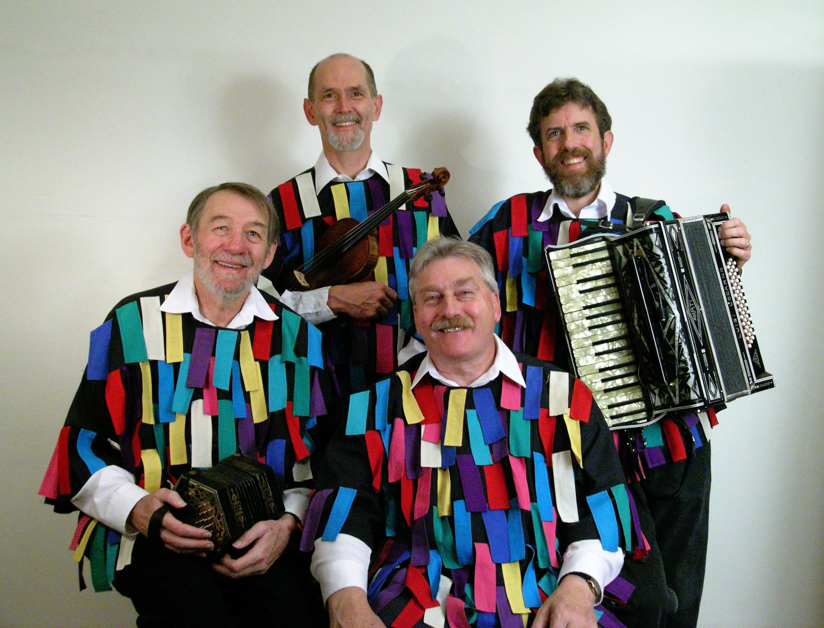
Norman Thomas High School, 111 East 33rd Street (at Park Avenue), New York, NY
This will be the thirty-fourth touring season of Nowell Sing We Clear with its unusual songs, carols, stories, and customs. Drawn mostly from English-language folk traditions, the songs tell both a version of the events and characters involved in the Christmas story and detail the customs which make up the twelve magical days following the return of the light at the winter solstice. Many of these ancient customs are the basis of the today's holiday traditions, such as visiting and feasting, gift-giving, carol singing from door-to-door and the adorning of houses and churches with garlands of evergreen.
The concert will start at 3:30 PM at Norman Thomas High School, 111 East 33rd Street (at Park Avenue), New York 10016. Concert admission is $25; Full-time Students (under 23) $15 . Tickets can be purchased at the door, or on line at: www.nowell.eventbrite.com. For information look on the web at www.folkmusicny.org or call 212-957-8386.
Nowell Sing We Clear celebrates Christmas as it was known for centuries in Britain and North America and as it continues in many places to the present. The songs come from an age when the midwinter season was a time for joyous celebration and vigorous expression of older, perhaps pagan, religious ideas. There is not always a clear line between these and the rejoicing at the birth of Jesus bringing a fresh light into the world at this dark midwinter time. A special and unusual treat is the enactment of a Mummers Play from Kentucky. Performed in the traditional manner, the play is typical of folk dramas which survive to this day throughout Britain and North America symbolizing and portraying the death of the land at midwinter and its subsequent rebirth in the spring. Performers are John Roberts and Tony Barrand, widely known for their lively presentations of English folk songs, and Fred Breunig and Andy Davis, well known in New England as dance callers and musicians.
While much of the singing is done in unaccompanied style, the pageant is also stamped with the energetic dance band sound of fiddle, button accordion, electric piano, drums, and concertina. The audience will be supplied with songsheets and encouraged to sing along, though after three decades of touring in New England, a whole generation of young people have grown up with these songs and carols and sing along with as much as they can. Some "new," that is "different", songs and carols are introduced every year. Recordings of songs from the concert are available from Golden Hinds Records.
The Folk Music Society of New York, Inc. hosts concerts for music lovers who can relax and listen, sing along on the chorus, or dance in the aisles to the best of traditional music. For more information go online to www.folkmusicny.org.
-- 00 --
Pictures and an electronic version of this release are at http://www.folkmuiscny.org/press.
Accredited members of the press are always welcome at our events. Tear-sheets are appreciated. Press contact Rosalie Friend, (718) 965-4074, a.friend@mindspring.com, for further information.
The Folk Music Society of New York, Inc. / New York Pinewoods Folk Music Club is a non-profit 501(c)(3) educational corporation, an affiliate of the Country Dance and Song Society of America and a member of the Folk Alliance. It is run by a volunteer Board of Directors, elected by the membership. For "do-it-yourself singers” we host informal participatory singing four times a month: sea chanteys, sacred harp, a community open sing, and gospel/sacred harp We also run concerts, weekends, classes, and singing parties, all with an emphasis on traditional folk music of all flavors. Office: 444 West 54th St, #7, New York NY 10019.
Visit our website: www.folkmusicny.org

