Folk Music Society of New York, Inc. / New York Pinewoods Folk Music Club
Please Announce:
Concert: Nordet: Breton Songs of the Sea

Friday, June 18: 8pm
OSA, 220 E. 23rd Street, suite 707, NYC, 10010
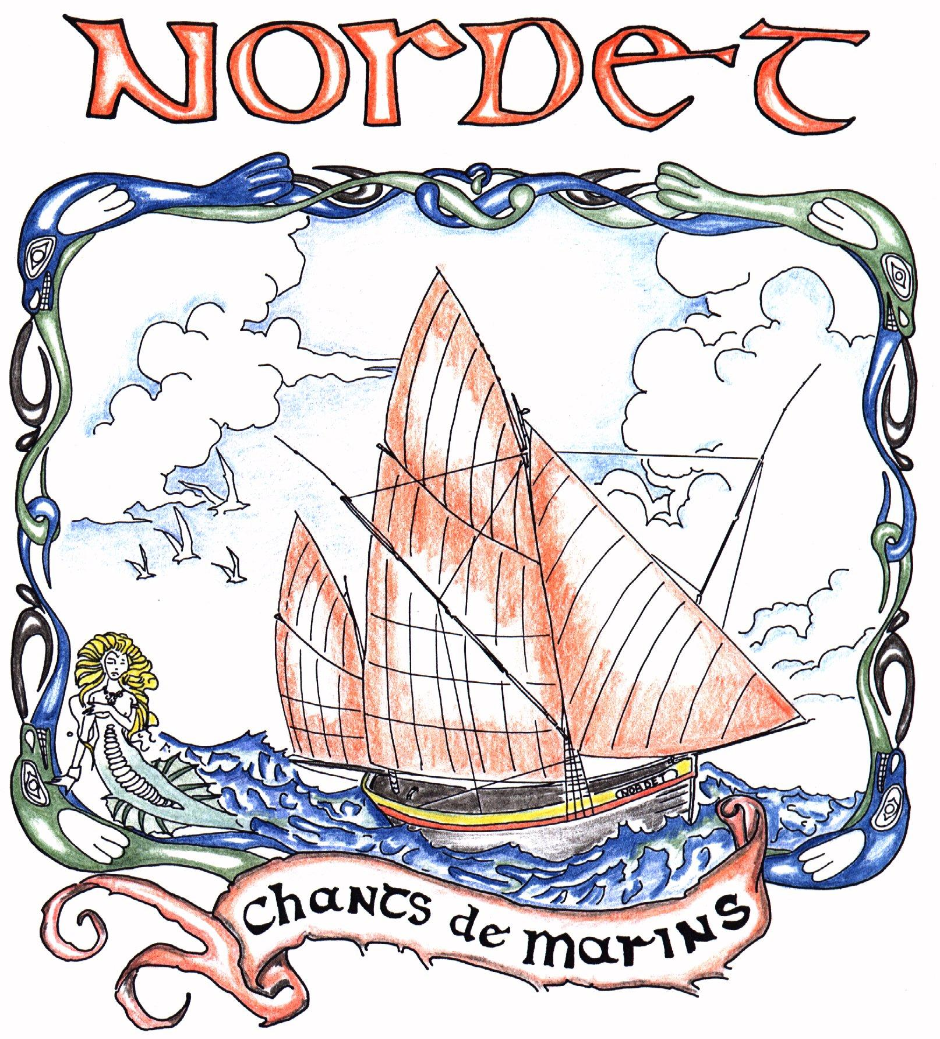
Nordet, a prize winning quartet of chanteymen from Brittany, is appearing in the United States for the first time after representing France in the Netherlands at the International Chantey Festival celebrating the 400th anniversary of the Dutch-India Company. They perform traditional Breton songs, working songs of both Atlantic coasts, and related traditional and contemporary compositions, wowing crowds throughout Europe. All four men are masterful singers: Pierre Guillemot plays the bodhran, Francis Arzul, the flute and diatonic accordions, Daniel Lafontaine the bouzouki, violin, and guitar, and Philippe Falquerho the guitar. The interplay of their singing and instrumentals forms a compelling whole that leaves audiences calling for more. They had started singing as children. formed a singing group in the 1990’s, and have continued presenting sea music with a mixture of humour and reverence.
Join in the music on Friday, June 18, at 8:00 pm at OSA, 220 E. 23rd Street, suite 707, between 2nd and 3rd Avenues. General Admission is $20. Children and full-time students under 23 are free; members of the Folk Music Society, $10. Tickets are available at the door or online at www.brownpapertickets.com/event/111587. Information: www.folkmusicny.org; or 718-672-6399.

The Folk Music Society of New York, Inc. hosts concerts for music lovers who can relax and listen, sing along on the chorus, or dance in the aisles to the best of traditional music. For more information go online to www.folkmusicny.org.

-- 000 –

Pictures and an electronic version of this release are available at http://www.folkmusicny.org/press.
If you would prefer to receive these notices via e-mail, please tell us at: publicity@folkmusicny.org
Accredited members of the press are always welcome at our events. Tear-sheets are appreciated. Press contact Rosalie Friend, (718) 965-4074, a.friend@mindspring.com, for further information.
The Folk Music Society of New York, Inc. / New York Pinewoods Folk Music Club is a non-profit 501(c)(3) educational corporation, and an affiliate of the Country Dance and Song Society of America. It is run by a volunteer Board of Directors, elected by the membership. For "do-it-yourself singers” we host informal participatory singing four times a month: sea chanteys, sacred harp, a community open sing, and gospel/sacred harp. We also run concerts, weekends, classes, and singing parties, all with an emphasis on traditional folk music of all flavors. Office: 444 West 54th St, #7, New York NY 10019.
Visit our website: www.folkmusicny.org
5/2/10

