Folk Music Society of New York, Inc. / New York Pinewoods Folk Music Club

Joy Bennett and Chris Koldewey
Free House Concert in Sparrowbush, NY, Sunday, Sept. 18th

For immediate release: August, 2011

Contact: 845-858-7890 John Ziv and Deborah Rubin
212-662-6575 594 Rte 97
rte97music@earthlink.net Sparrowbush, NY 12780
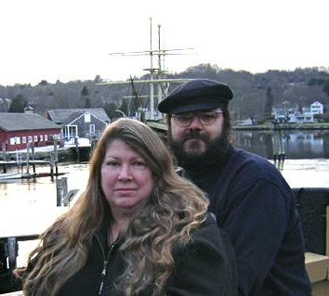
Noted traditional folk musicians Joy Bennett and Chris Koldewey will perform at a house concert on Sunday, September 18 at 2:00 pm at 594 Rte. 97 in Sparrow Bush, NY.

Admission is free.

Joy Bennett has been involved in folk music most of her life. As a member of the quartet Water Sign for 13 years, she explored the close-knit harmonies of both traditional and contemporary folk music. Joy is also a founding member of the all woman chantey group The Johnson Girls. The “J-Girls” bring a sound and energy to sea and work songs that has brought entire audiences to their feet. They not only have beautiful harmonies, but raw power, allowing audiences a glimpse of the situations in which the chanteys were used. At the same time, the beauty of their ballads is unparalleled. Joy has performed solo, with Water Sign, the Johnson Girls, and with guest artists in the US and Europe.

Chris Koldewey, has been singing folk music and sea music in particular since his early teens. He comes from a family rich in maritime traditions, and his lullabies as a child were traditional songs of the sea Chris has played many concerts and festivals in states along the US eastern seaboard and internationally, and has led workshops dealing with a variety of traditional music forms. He accompanies himself on guitar, banjo, fiddle, concertina. His powerful singing voice is remarkably well suited to sea music, and he has performed on board many times.

When Chris and Joy come together for concerts, leading workshops or organizing events, they deliver powerhouse chanteys, haunting ballads, and tender laments rich with harmonies sung either a capella, or accompanied by Chris on one of his many instruments. Their repertoire will often move far away from water, perhaps to the mountains with an old-time song, or to some distant land with a ballad. Joy and Chris encourage audience participation audience members will leave with a new song running through their heads.

This concert is the 7th annual concert presented by John Ziv and Deborah Rubin in Sparrowbush, NY. Previous performers included Andy Cohen, Neil Rossi and Tom Akstens, Jeff Warner, John Roberts, Jerry Epstein and Keith Kendrick. The location on Rte 97 is very scenic, with views of the Delaware River and Pennsylvania, just north of the Hawk’s Nest.

This concert is a program of the Folk Music Society of New York; The Folk Music Society of New York, Inc. hosts concerts for music lovers who can relax and listen, sing along on the chorus, or dance in the aisles to the best of traditional music. For more information go online to www.folkmusicny.org.
----------------------- 000 ----------------------
photos and an electronic version of this release are available at: http://www.folkmuiscny.org/press
Press contact Rosalie Friend, (718) 965-4074, publicity@folkmusicny.org, for further information or to receive releases by e-mail in the future.
The Folk Music Society of New York, Inc. / New York Pinewoods Folk Music Club is a non-profit 501(c)(3) educational corporation, an affiliate of the Country Dance and Song Society of America. It is run by a volunteer Board of Directors, elected by the membership. It runs concerts, weekends, classes, singing parties, and get-togethers, all with an emphasis on traditional folk music of all flavors. Office: 444 W. 54th St, #7, NY, NY 10019
www.folkmusicny.org

