Folk Music Society of New York, Inc. / New York Pinewoods Folk Music Club
Please Announce: [Release date: Feb. 16, 2009 -- For immediate release.]
American Swing Music and Blues Concert
Housetop, Friday, March 13, 2009 at 7:30 PM
At The West Side Arts Coalition,
Broadway Mall Center Island at 96th and Broadway, N.Y.C.
Housetop is a harmony singin', swingin' string band quartet based in Southern Vermont and here in New York City for a special appearance. They perform a lively, quirky program of swingy, bluesy, old time American music. Much of Housetop's repertoire is from the 30s and 40s -a high point of American song writing as performed at the time by stars like the Ink Spots, The Boswell Sisters, Fats Waller, and Fred Astaire. It was a time of great musical craftiness: close harmonies and clever, concise lyrics. It's also the music with which entertainers strove to sing and dance the people's cares away, and there's an undertone of hard times, treading the line between sincerity and satire. In the irreverent spirit of Vaudeville, Housetop makes these songs their own, along with whatever else scratches their itch, including jug band tunes, songs penned by Bob Wills, Dan Hicks, the Roches, and their own originals. They'll round out the program with hot instrumentals: Peter and Erica set the groove for Anna and Naomi's wild renditions of raggy fiddle tunes and little-big-band breaks.
The concert will start at 7:30 PM at The West Side Arts Coalition, in the Broadway Mall Center Island at 96th and Broadway, Manhattan. General Admission is $15. Children and full-time students, $6. Seating limited so call 718-672-6399 right away for reservations. Tickets may be available at the door if there is still space. For information call 718-672-6399 or see www.folkmusicny.org.
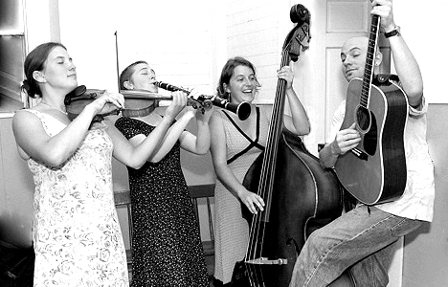
The group consists of Naomi Morse (vocals, fiddle and mandolin), Erica Morse (vocals and upright bass), Anna Patton (vocals and clarinet), and Peter Siegel (vocals, guitar and mandolin). They are four busy and versatile musicians: Naomi Morse is an expressive soprano and a fiery, lyrical fiddler whose rhythmic Vermont style sparks with French Canadian and southern old-time influences. She has performed throughout the US and in Europe, and now sings professionally in New York City. Erica Morse is an expert singer, rendering jazzy harmonies with her rich, clear tone. Drawing on a musical background of intensive study of the viola de gamba and cello, these days she can often be seen thumping out a lovely big fat tone on the upright bass. A resident of Brattleboro, Erica moonlights as a first and second grade teacher. Anna Patton is a third generation singer, musician and arranger of jazz vocal harmonies. An accomplished, versatile clarinetist, Anna tours regularly, delighting audiences with her command of numerous genres, her soulful style and her stunning musicianship. She appeared recently in the twilight music series with the Will Patton Quartet. Peter Siegel is a mainstay of the traditional dance scene of the Pioneer Valley, as well as a composer and nationally-known singer-songwriter. His unique brand of "space age vaudeville" features hip-hop, finger style blues, fiddle tunes from Ireland, Quebec, New England, Appalachia, swing, funk, and country songs with lots of yodeling.
-- 000 --
Pictures and an electronic version of this release are at http://www.folkmuiscny.org/press.
If you would prefer to receive these notices via e-mail, please let us know at publicity@folkmusicny.org
Accredited members of the press are always welcome at our events. Tear-sheets are appreciated. Press contact Rosalie Friend, (718) 965-4074, a.friend@mindspring.com, for further information.
The Folk Music Society of New York, Inc. / New York Pinewoods Folk Music Club is a non-profit 501(c)(3) educational corporation, an affiliate of the Country Dance and Song Society of America and a member of the Folk Alliance. It is run by a volunteer Board of Directors, elected by the membership. For "do-it-yourself singers” we host informal participatory singing four times a month: sea chanteys, sacred harp, a community open sing, and gospel/sacred harp We also run concerts, weekends, classes, and singing parties, all with an emphasis on traditional folk music of all flavors. Office: 444 West 54th St, #7, New York NY 10019.
Visit our website: www.folkmusicny.org

