PRESS CONTACT: FOR IMMEDIATE RELEASE
Heather Wood Please announce
hwood50(at)aol.com
646-628-4604
Folksinger Archie Fisher In Concert, Thursday, June 27
On Thursday, June 27th at 7:30, the Folk Music Society of New York presents Scottish folk singer Archie Fisher at the Second Presbyterian Church, 6 West 96th St., at Central Park West. Contribution: general public $25, members $20.
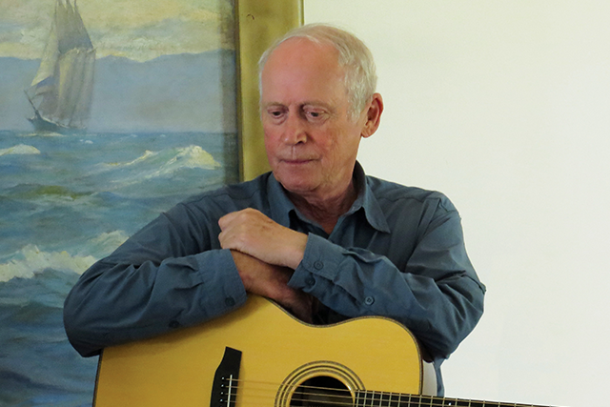
Archie Fisher is one of Scotland’s foremost folksingers/songwriters. Archie was born in Glasgow into a large singing family. His father’s appreciation of many musical styles (opera, vaudeville, traditional ballads) proved to be a heavy influence on Archie’s music, while his mother, a native Gaelic speaker from the Outer Hebrides, influenced the lyrical quality of his songwriting. As well as being a gifted songwriter, Archie, who was and an early guitar colleague of Bert Jansch, is a master guitarist.
Recognized for his contributions to Scottish folk music, in 2007 he was inducted into the Scots Traditional Music Hall of Fame and in 2006 was awarded an MBE for services to traditional music. The most recent recognition of his art came in 2008 when he was granted the Tradition Bearers Award from the Goderich Celtic Roots Festival in Canada. Archie’s musical agility and inventive compositions hold his audiences spellbound.
Tickets may be purchased online at: http://ArchieF.eventbrite.com, or at the door on the night of the concert

###

