PRESS CONTACT: Please announce
Heather Wood FOR IMMEDIATE RELEASE
hwood50@aol.com; 646-628-4604

HAPPY TRAUM IN CONCERT, Friday, March 1; 7:30pm
On Friday, March 1, at 7:30 PM, the Folk Music Society of New York presents Happy Traum, with special guest Kenny Kosek, at St. John’s Lutheran Church, 81 Christopher St., New York, NY. Contribution: general public $25, members $20.
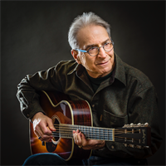
Happy Traum was smitten by American folk music as a teenager and began playing guitar and 5-string banjo. He was an active participant in the legendary Washington Square/Greenwich Village folk scene of the 1950s and ‘60s, and studied guitar with the famed blues master, Brownie McGhee. According to Folk Roots and Folk Branches, "Happy has impeccable taste in choosing a program of great traditional folk and blues songs or contemporary songs written in the tradition and even better taste in the way he arranges them with both reverence for his sources and the originality of his always creative fingerpicking guitar and warm singing". Kenny Kosek, one of America's finest fiddlers, has played and recorded with numerous bluegrass and new acoustic bands, including Country Cooking, Breakfast Special, Bill Keith and Tony Trischka.
Tickets available at the door or online at http://happytraum.eventbrite.com
Be prepared for an evening of folk music at its best. St. John’s Lutheran Church is located at 81 Christopher St., and can be reached via the Christopher St. stop on the 1 train.
- # # # -

