PRESS CONTACT: FOR IMMEDIATE RELEASE
Heather Wood Please announce
hwood50@aol.com; 646-628-4604

Tannahill Weavers, Scottish Folk Group In Concert: March 29, 2019
On Friday, March 29, 2019, at 7:30pm, the Folk Music Society of New York presents The Tannahill Weavers at the Second Presbyterian Church, 6 West 96th St. (at Central Park West), New York, NY. Contribution: general public $25, members $20.
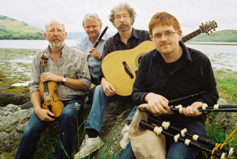
The Tannahill Weavers are one of Scotland's premier traditional bands. Their diverse repertoire spans the centuries with fire-driven instrumentals, topical songs, and original ballads and lullabies. Their music demonstrates to old and young alike the rich and varied musical heritage of the Celtic people. These versatile musicians have received worldwide accolades consistently over the years for their exuberant performances and outstanding recording efforts that seemingly can't get better...yet continue to do just that.
Tickets available at the door or online at http://tiny.cc/tannahill
This promises to be an exciting evening of traditional Celtic music presented in both old and new, unexpected, ways. The Second Presbyterian Church is at 6 West 96th St., on the corner of Central Park West, and can be reached via the 96th St. stop on the C or B train.
- # # # -

