PRESS CONTACT: FOR IMMEDIATE RELEASE
Heather Wood Please announce hwood50@aol.com
646-628-4604
The Folk Music Society Of New York Presents a Concert of Old-Time Music:
Ben Paley, with Lonely Street (Bill Christophersen and Aron Weinbach)
Friday, September 13, 2019, 7:30pm
at St. John’s Lutheran Church, 81 Christopher Street, New York, NY
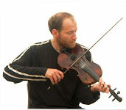
Born in London, Ben Paley, son of Tom Paley of the New Lost City Ramblers, was surrounded by traditional music all his life. Besides his father, Tom’s mother, singer Claudia Gould, and step-father, Ron Gould, writer on jazz, country and folk music, were all enormous influences. At 6 years old, Ben began playing the fiddle, taking formal violin lessons as well as learning traditional tunes. When he was 9, they moved to Morganton, North Carolina, where Ben began to learn about harmony, improvisation, and playing nicely with others.
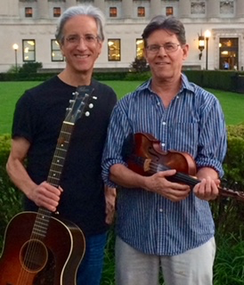
Lonely Street combines the talents of Bill on fiddle and Aron on guitar (plus vocals and other instruments from the pair). Their repertoire ranges from bluegrass to country, to the brothers Everly, Louvin, and Stanley, and more.
Tickets available at the door or online at https://benpaley.eventbrite.com
This promises to be an exciting evening of traditional American music and more. St. John’s Church, 81 Christopher St., can be reached by the 1 train, Christopher St. stop. For more information, contact Heather Wood, 646-628-4606
-###-

