PRESS CONTACT: FOR IMMEDIATE RELEASE
Heather Wood Please announce
hwood50(at)aol.com; 646-628-4604
Larry Kaplan: In Concert, Friday, May 31; Workshop, Saturday, June 1
On Friday, May 31st, at 7:30pm, the Folk Music Society of New York presents Larry Kaplan in concert, at Pearl Studios in Manhattan, 500 Eighth Avenue, Room 304 (between 35th and 36th Streets). Contribution: general public $25, members $20.
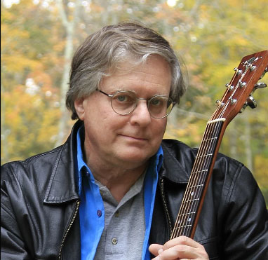
Larry Kaplan, whom Sandy Paton (founder of Folk Legacy Records) called “One of the best song-makers in the folk song revival”, is a multi-instrumentalist singer and songwriter. His poignant, finely crafted songs, including “Old Zeb," “Song for Gale," "Song for The Bowdoin," “John,” “Get Her Into Shore,” and “Selling The Isabel” are considered some of today’s finest folk ballads. Larry is the recipient of multiple best folk CDs of the year, awarded by leading folk radio programs across the US and Europe. Larry’s songs are respectful of tradition, honest, engaging, memorable, and highly singable.
Tickets available at the door or online at https://larrykaplan.eventbrite.com. Pearl Studios is at 500 Eighth Avenue, Room 304, and can be reached by the A, C, or E train to the 34th St. stop. For more information, contact Heather Wood, 646-628-4606.
- # # # -

