PRESS CONTACT: FOR IMMEDIATE RELEASE
Heather Wood Please announce
hwood50@aol.com; 646-628-4604

Hubby Jenkins In Concert; Friday, May 3, 2019

On Friday, May 3rd, at 7:30, the Folk Music Society of New York presents Hubby Jenkins, at Pearl Studios in Manhattan, at 500 Eighth Avenue, Room 304 (between 35th and 36th St). Contribution: general public $25, members $20.
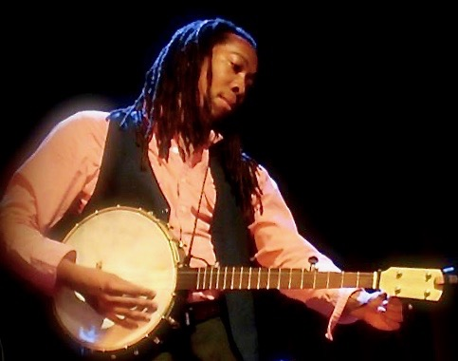
Hubby Jenkins is a talented multi-instrumentalist who endeavors to share his love and knowledge of old-time American music. Born and raised in Brooklyn, he delved into his Southern roots, following the thread of African American history that wove itself through country blues, ragtime, fiddle and banjo, and traditional jazz. Since 2010 he has been an integral part of the Grammy winning Carolina Chocolate Drops.
Tickets available at the door or online at https://hubbyjenkins.eventbrite.com
This promises to be an exciting evening of authentic and soulful interpretations of traditional American music. Pearl Studios is at 500 Eighth Avenue, Room 304, can be reached by the A, C, or E train to the 34th St. stop. For more information, contact Heather Wood, 646-628-4606.
Next Concert: Friday, May 31: Larry Kaplan, same location.
- # # # -

