PRESS CONTACT: FOR IMMEDIATE RELEASE
Heather Wood Please announce
hwood50(at)aol.com
646-628-4604
Tim Eriksen in Concert, Friday, January 18, in Greenwich Village
On Friday, January 18th, at 7:30, the Folk Music Society of New York presents Tim Eriksen at St. John’s Lutheran Church, 81 Christopher St., New York, NY. Contribution: general public $25, members $20.
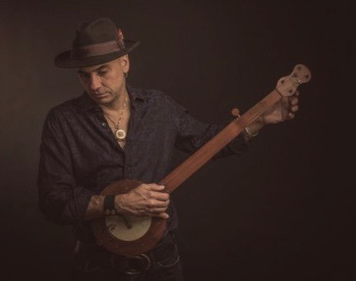
Tim Eriksen’s musical journeys have included everything from punk rock, shape note gospel, South Indian classical and Bosnian pop, to world jazz and contemporary symphonic music. Yet all his explorations are linked by qualities of intensity, directness, and authority. Eriksen is acclaimed for transforming American traditional music with his startling interpretations of old ballads, love songs, shape-note gospel and dance tunes from New England and Southern Appalachia. He combines hair-raising vocals with inventive accompaniment on banjo, fiddle, guitar and bajo sexto (a twelve string Mexican acoustic bass), creating a distinctive hardcore Americana sound.
Tickets available at the door or online at bit.ly/timeriksen.
This promises to be an exciting evening of traditional music presented in both old and new, unexpected ways. St. John’s Lutheran Church is located at 81 Christopher St., and can be reached via the Christopher St. stop on the 1 train. Information: 646-628-4604
- # # # -

