The Folk Music Society of NY, Inc
(New York Pinewoods Folk Music Club)
Presents a House Concert at the Home of Helen Engelhardt
Appalachian Music Sung by Folklorists & Oral Historians

Michael and Carrie Kline

Friday, December 5, 8:00 p.m.
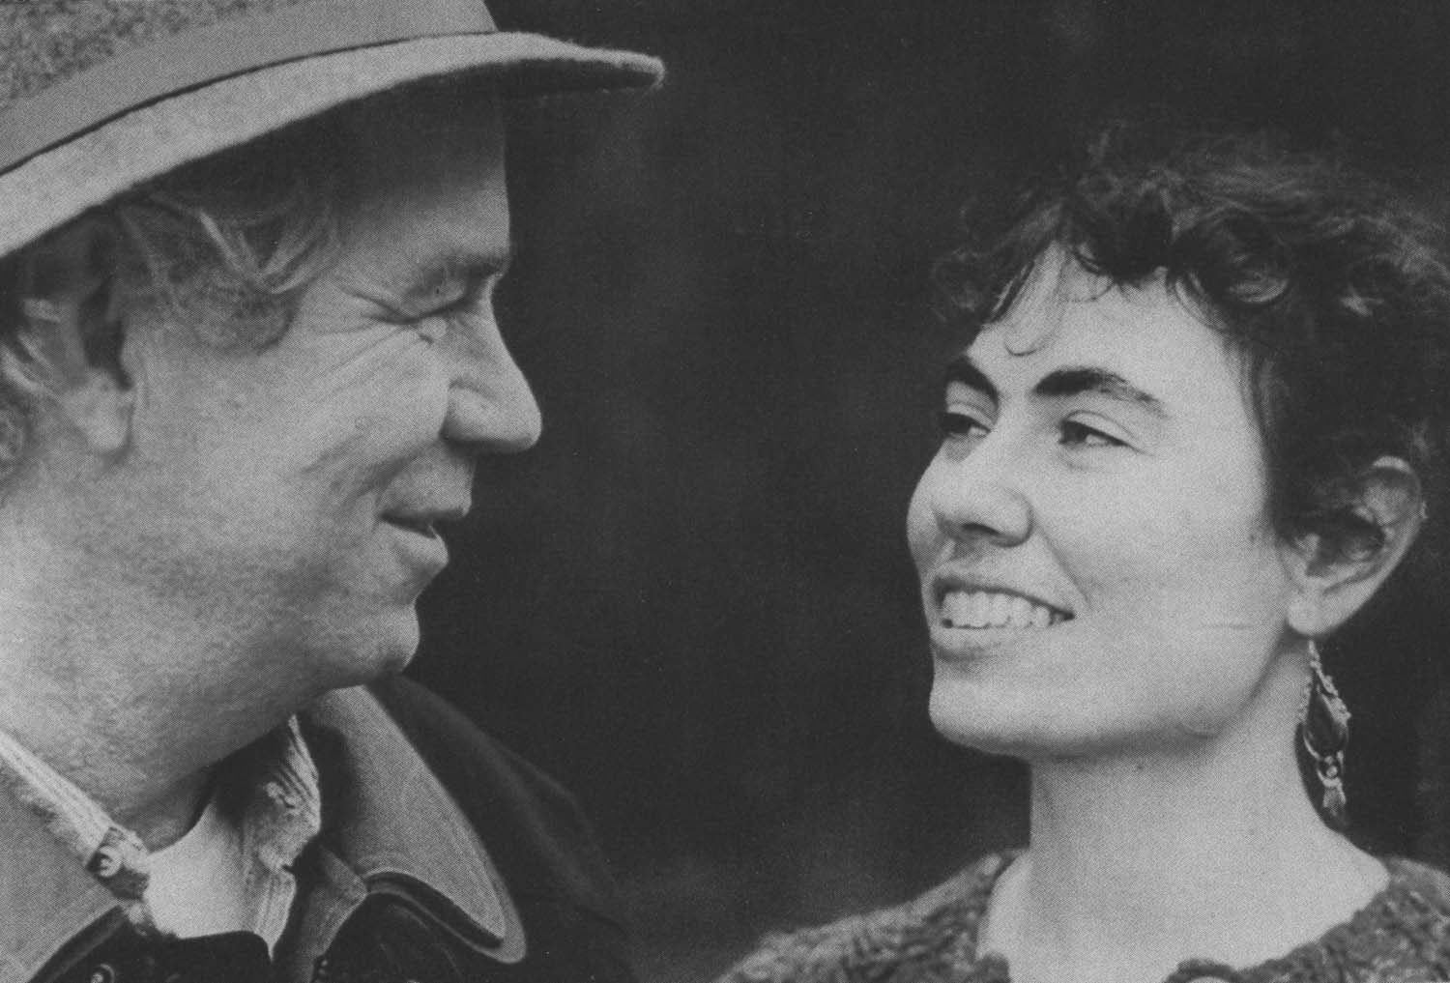

Mountain Music

For These Times

“We are preoccupied with Appalachian songs, from the ancient ballads of the Hammons family in the West Virginia highlands, to mining laments and songs of resistance in the coalfields, to songs of urban Appalachian refugees. We enjoy love ballads, country songs, and contemporary celebrations of the great outdoors in song.”
The Klines present their music both as entertainment and social history, with engaging ease and hard-hitting passion.
Michael and Carrie’s musical style is a blend of their years recording music and spoken narrative in Cherokee, North Carolina, the Appalachian coalfields, and industrial cities from Cincinnati to New England. Their high mountain harmonies meld with Michael Kline’s melodic flat-picking guitar playing. Their CDs featuring regional history, music and folklife will be on hand.

Songs of Home, Love & Longing

Join Michael and Carrie as they celebrate life, love, friendship, and their CDs Eyes of a Painter and Patchwork. This harmony-weaving duo will present a wide variety of material – from traditional music of the southern Appalachian Mountains to the contemporary country ballads of songwriters such as Kate Wolf, David Norris and Hazel Dickens. Take time out for this intimate evening of duet singing backed by Michael’s distinctive guitar style. Join us for an evening of living room music. To hear the Klines go to www.myspace.com/carriemichaelkline
or http://www.folktalk.org/wc.html.

.

RSVP to Helen by calling 718-859-5440.
FMSNY Members $12, non-members $15,
Children and F/T students $6, Seniors $10
Neighborhood is South Midwood, Flatbush Brooklyn
Near Brooklyn College, served by Q&B and #2 subway lines
The Folk Music Society of New York, Inc., a not-for-profit membership organization commonly known as the New York Pinewoods Folk Music Club, sponsors folk music events, including concerts, weekend retreats, informal gatherings, educational workshops, and the annual Eisteddfod-NY traditional music festival.
For more information, please visit our website www.folkmusicny.org or call 718-651-1115

